Activity Name | Description |  | Diagram | Purpose/Coaching Points
1
Free Movement with the Ball.  Free Movement with the Ball at their Feet. | Every player has a ball in a 15 x 20 yd grid. Coach asks all players to move freely with their ball around the grid.  Coach then asks players to move freely with the ball at their feet. |  | - X.  X.  X. .X  X.  20 yds.  15 yds. | Movement education; repetition in ball touches; balance; eye-foot coordination; change of speed; change of direction; decision making.
2
Goofy Stop and Go |  | Same set up as above. All players dribble their ball in the grid. When coach says, “STOP!” Players must stop their ball and freeze in a goofy position. | Coach  .X  X.  - X.  X. X.  20 yds.  15 yds. | Same as above.
3
Body Part Dribbling |  | Same set up as above. All players dribble their ball in the grid. When the coach yells out a body part, the players must stop the ball with that body part. |  | Same as above.
4
Hit the Ball  (Relaxation Activity) |  | Players line up shoulder to shoulder on one end of the grid. Place 2 balls in the middle of the grid. One at a time players kick their ball and try to hit one of the balls in the middle. | X. X. X.  . .  X. X. X.  20 yds.  15 yds. | Rest from previous activities. The challenge of hitting a target.
5
Sharks and Minnows |  | The minnows, the players with a ball, line up shoulder to shoulder on one end of the grid. Two players are designated as sharks and are positioned inside of the grid without soccer balls. On the coach’s command, the minnows must dribble their ball through the grid and get to the other side without getting their ball stolen or kicked away by the sharks. If a player loses their ball while crossing the grid, he/she becomes a shark. | Coach  M. M. M. M.  S S  20 yds.  15 yds. | FUN…Dribbling under pressure; decision making; change of speed; change of direction; defending. This is an inclusive game…the players are either dribbling a ball or trying to get one back.
6
End Line Soccer |  | Set up a 15 yd x 20 yd grid. Divide the players into two teams. Play 3v3 with no goalkeepers on the field. A team scores by dribbling the ball or kicking the ball over their designated end line. Balls are served in one at a time by the coach who is positioned outside the field at midfield. | 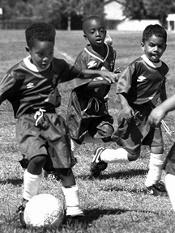 | FUN…Directional play. Dribbling under pressure; kicking; receiving; decision making; change of speed; change of direction; defending.
7
3v3 Soccer Match |  | Set up a 20 yd x 25 yd field with goals at each end. Divide the players into two teams. Play 3v3 with no goalkeepers on the field. Balls are served in one at a time by the coach who is positioned outside the field at midfield. | O  - X  O  X O  X  25 yds.  20 yds.  Coach | FUN…Directional play. Dribbling under pressure; kicking; receiving; shooting; decision making; change of speed; change of direction; defending.
8
Cool Down  Juggling |  | Every player starts with a ball in his or her hands. They drop the ball on their thigh and catch it. They progress to dropping the ball on one thigh and juggling it to the other thigh, then catch it. Eventually, they can try “thigh-thigh-foot-catch”, etc. | 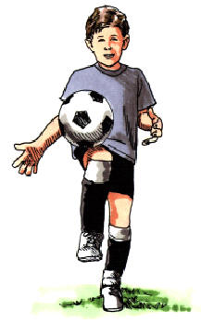 | FUN…challenging; balance; coordination.

